Plan: Troop 9 Philmont Trek--2011

Goal: Develop Confidence for the Philmont Trek
How: Through practice and preparation.
Preparation: By attention to detail.

- Meet with boys and parents to discuss equipment needs and training requirements. – March 2010
  - Personal Equipment -- Provide a list of equipment
  - Show examples of equipment
- Crew Equipment provided by Troop -- Buy half of the equipment in 2010 and half in 2011.
  - Tents
  - Back packing stoves
- First Aid Training -- “Philmont requires that a least one person, preferably two, (either an advisor and/or a youth participant) in each crew be currently certified in American Red Cross Wilderness First Aid or the equivalent* and CPR from the American Heart Association, the American Red Cross or the equivalent.”
  - Find the appropriate Red Cross training, register and attend.
  - All adult crew leaders & Any boys who want to attend
- Shakedown Trips – 4 back packing trips to prepare and practice.
  - Leave No Trace (LNT) – learn the aspects of LNT as part of our Philmont training.
- Team building. – 1 team building outing (a fifth outing).
  - October, 2010 - Trip --COPE Team building trip,
  - Design and Make Troop 9 Trek T-Shirts?

Shakedown Trips
Meals: Dehydrated meals cooked over backpacking stoves.
Water: Carry all needed water for each trip.
Tents: Use back packing tents when needed, otherwise, sleep in shelters.
How:
- Practice using our equipment
  - Packing to reduce weight
  - Packing to carry the weight in the most comfortable manner.
- Find out what works for each person and what does not work
  - Equipment one may have forgotten.
  - Equipment that does not perform
- Practice the skills needed for a successful Philmont Trek.
  - Map and compass reading.
  - Leave No Trace camping.
- Learn how to work together as a team.
- Proposed Shakedown Trips – All trips are leave Friday evening, return Sunday:
  - March, 2010 – Review Equipment
  - April or May 2010 – Shakedown Trip #1 (small overnight hike, 7 miles, as a start).
  - November-- 2010 -- Shakedown Trip #2, about 15 to 20 miles
  - April, 2011 Shakedown Trip #3, about 15 to 20 miles over 2 days
  - May, 2011 -- Shakedown Trip #4, about 15 to 20 miles over 2 days. Hilly ground, example – Shawnee National Forest
Time Line (Tentative): Philmont 2011 Trek

Line | Tentative Dates | Task or Event
 | Year - 2010
1 | February 12, 2010 | First Payment Due
2 | March, 2010 | Meet with Parents and Boys  - Provide personal equipment list  - Show examples of personal equipment
3 | April or May, 2010 | Shakedown trip #1, 7 to 10 mile hike, no tents.  Example: Kettle Moraine South.
4 | Fall of 2010 | Wilderness First Aid Basic and CPR certification – attendance mandatory for all adults
5 | Fall of 2010 #1 | Trip #2--COPE Team building trip, Milwaukee or Davenport
6 | Fall of 2010 #2 | Shakedown Trip #3, about 15 to 20 miles over 2 days  Example: Kettle Moraine North
7 | October 1, 2010 | Second payment due to Philmont
 | Year – 2011
8 | January 1, 2011 | All youth members age 14 by 1/1/2011 or completed 8th grade be at least 13 by date of attendance.
9 | March 1, 2011 | Final payment due Philmont  Receive trek options after final payment is made.
10 | March 1, 2011 | Trek choices mailed (no later than May 1, 2011)
11 | April, 2011 | Shakedown Trip #4, about 15 to 20 miles over 2 days
12 | May, 2011 | Shakedown Trip #5, about 15 to 20 miles over 2 days.  Hilly ground, example – Shawnee National Forest.
13 | June 1, 2011 | File National Tour Permit (needed 30 days before)  Buy train tickets, Amtrak 800-872-7245
14 | June 1, 2011 | Philmont Health and medical Records complete with physician and parent/guardian signature
15 | June 1, 2011 | Wilderness First Aid Basic and CPR certification completed with proof of certification.
16 | June 1, 2011 | Trek Itinerary reservation confirmed by Philmont
17 | July 1, 2011 | Arrival Plans and Crew Information Card mailed to Philmont mailed at least 30 days before.
18 | August 11, 2011 | Board Train to Raton, NM, for Philmont, Departs: 3:15 PM
19 | August 12, 2011 | Arrives: 10:56 AM, Aug 11 2010, spend night at Philmont Ranch
20 | August 12-19, 2011 | Arrive at Philmont between 8-11am for Philmont Trek  Friday, Aug 12 through Friday, Aug 19, 2011.
21 | August 19, 2011 | Board Train, Departs: 5:32 PM at Raton, NM, for Home
22 | August 20, 2011 | Arrives: 3:20 PM at Union Station, Chicago, IL

Crew Equipment & Transportation
REI Quarter Dome T2 Tent  Item # 761893  $269.00 | 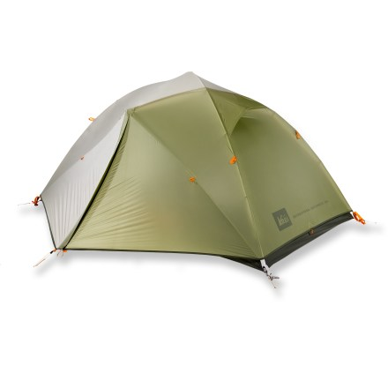
REI Camp Dome 2 Tent  Item # 731378  $99.50 | 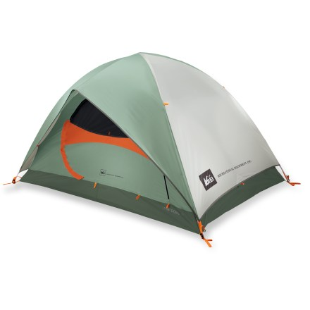

MSR DragonFly Backpacking Stove  Item # 709002  $129.95 | 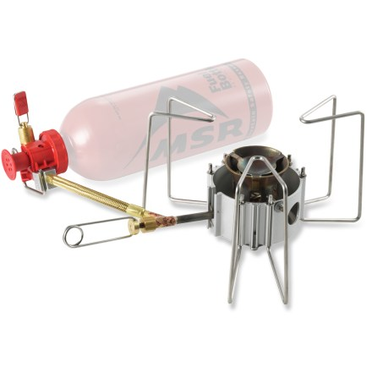
MSR Fuel Bottle with CRP Cap - 30 fl. oz.  Item # 783963  $19.95 | 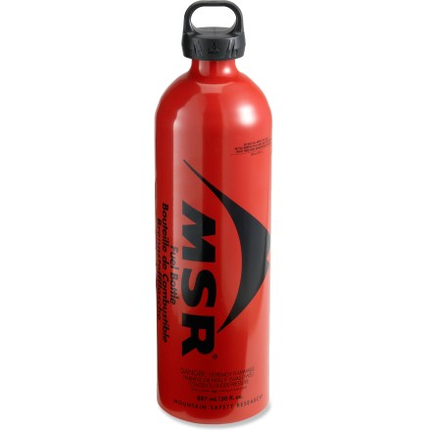

Transportation

Between Raton, NM and Union Station, Chicago
CHI to RAT | From: Chicago - Union Station, IL (CHI)  To: Raton, NM (RAT)  Departs: 3:15 PM, Tue Aug 10 2010  Chicago, IL - Union Station (CHI)  Arrives: 10:56 AM, Wed Aug 11 2010  Raton, NM (RAT) | Afternoon $121.00  Duration: 20 hr, 41 min
RAT to CHI  4 Southwest Chief | Departs: 5:32 PM, Fri Aug 20 2010  Raton, NM (RAT)  Arrives: 3:20 PM, Sat Aug 21 2010  Chicago, IL - Union Station (CHI) | Afternoon $121.00  Duration: 20 hr, 48 min
 |  | Total Cost $242

